# **Practical – 1**

**Aim: Basic Python programs. [ NumPy, Panda, Matplotlib]**

1. **Creating blank array with predefined data**

import numpy as np

import pandas as pd

import matplotlib.pyplot as plt

standings = np.array([575, 285, 234, 206, 206, 205, 200, 175, 97, 62])

1. **Slicing and Updating elements.**

# ! Slicing

arr = standings[:4]

print("Data slicing: ", arr)

# ! Updating

standings[0] = 576

# ! Printing updated data

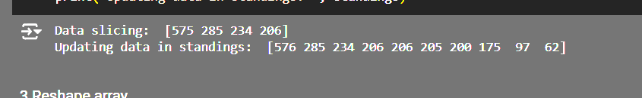print("Updating data in standings: ", standings)

1. 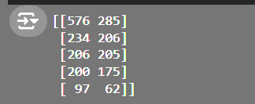**Slicing and Updating elements.**

# ! Reshaping

newarr = standings.reshape(5, 2)

print(newarr)

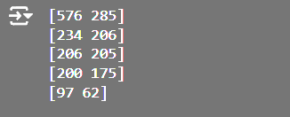

1. **Looping in numpy**

for i in newarr:

print(i)

1. **Read csv file in numpy**

from google.colab import drive

drive.mount('/content/drive')

data_set = pd.read_csv("/content/drive/MyDrive/temp/prac_1.csv")

1. 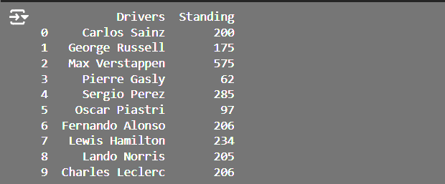**Create a dataframe**

df = pd.DataFrame(data_set)

print(df)

1. **Slicing in created dataframe**

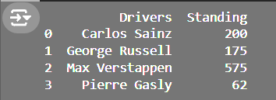print(df.iloc[:4])

1. **Column and Row manipulation**

np.transpose(data_set)

1. **Importing matplotlib and make simple line chart**

plt.plot(df["Drivers"], df["Standing"])

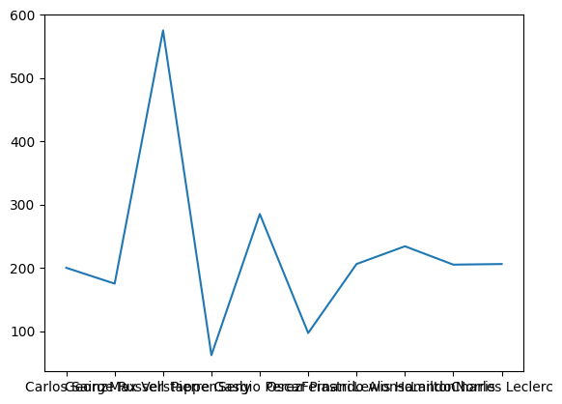plt.show()

1. **Make histogram**

# ! Creating a histogram for standings

plt.hist(df["Standing"], bins=10, color='blue', edgecolor='black')

plt.title("Driver's Standings")

plt.xlabel("Standings")

plt.ylabel("Frequency")

plt.show()

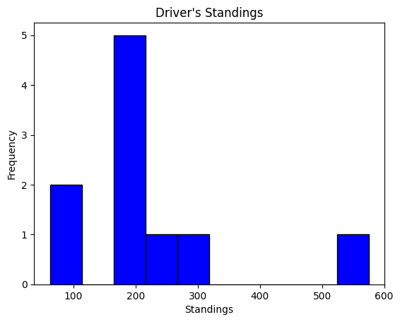

1. 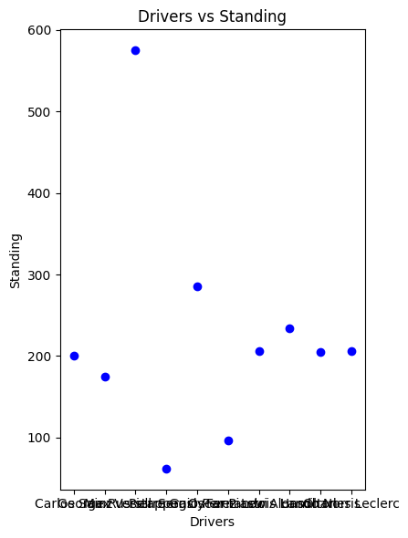**Plotting multivariate data**

plt.figure(figsize=(12, 6))

# ! Plot 1: Drivers vs Standing

plt.subplot(1, 3, 1)

plt.scatter(df["Drivers"], df["Standing"], color='blue')

plt.title("Drivers vs Standing")

plt.xlabel("Drivers")

plt.ylabel("Standing")

plt.tight_layout()

plt.show()

1. **Plotting pie chart**

plt.figure(figsize=(8, 8))

plt.pie(df["Standing"], labels=df["Drivers"], autopct='%1.1f%%', startangle=90, colors=plt.cm.tab20.colors)

plt.title("Standings Distribution by Drivers")

plt.show()

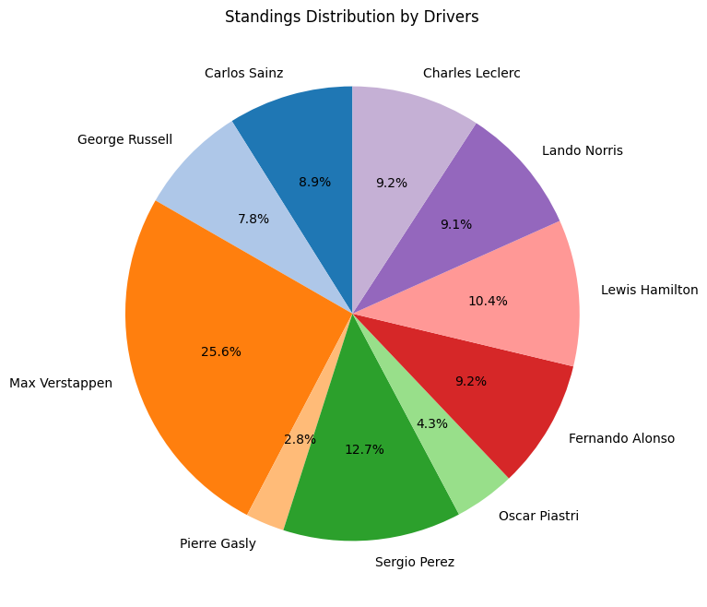

Faculty Signature: _______________ Date: _____________________